Faculty of Engineering and Management
Global Foresight and Technology Management

Project Future Life Worlds
The Future of EXPO World Exhibition

Submitted by:

● Zhanl Mamykova. Matr. No.00172672
● Haroon Marzook. Matr. No. 00172055
● Abdul Razaque Pirzado. Matr. No. 00164580
● Bhushan Shirsath. Matr. No. 00172884
● Shubham Jawale. Matr. No.00172581
● Mangesh Bharat Borude. Matr. No. 00171191

Examiner: Prof. Jan Oliver Schwarz
Date of Issue:
Date of Submission: 07.07.2025

Declaration
We hereby declare that the work has been written independently, has not been submitted elsewhere for examination purposes, has not used any sources or aids other than those indicated, and that verbatim and analogous quotations have been marked as such.

Ingolstadt,
7th of July 2025.

Abstract

This report explores the evolving future of mass events through the lens of strategic foresight, with a particular focus on the Expo 2035 World Exhibition in Berlin. It applies structured foresight methods to analyze political, economic, social, technological, environmental, and legal (PESTEL) trends shaping the design, experience, and impact of large-scale events beyond 2035.
The project begins by contextualizing the historical and conceptual foundations of World Expos, emphasizing their transition from industrial showcases to platforms for public diplomacy, innovation, and global dialogue. Building on this foundation, the report presents a focused analysis of environmental and economic trends developed by our team as part of the broader Expo 2035 trendbook. These trends include hydrogen-based steel production, decentralized energy cooperatives, circular economy practices, biotechnology in urban farming, and preparedness for climate change through sustainable urban development.
A key contribution is the Assessment of Relevance and Uncertainty, which maps critical drivers and assumptions influencing the future of mass events. This leads to the construction of four future scenarios that contrast livability and cultural diversity under conditions of climate resilience and evolving government control regimes. Each scenario is brought to life through immersive storytelling, scenario blueprints, and AI-generated media prototypes. To illustrate how these scenarios might be experienced by individuals, we developed detailed personas representing diverse backgrounds, values, and levels of digital access. Their journeys through holographic interfaces, emotionally intelligent AI companions, and hybrid physical-digital spaces reveal not only how users interact with future Expos, but also how they think, feel, and form connections in speculative urban futures shaped by inclusion, exclusion, and technological transformation.
The project included the development of a website that included the main results of the project, as well as videos created using AI tools based on the team's original prompts.
The report concludes with scenario-based insights into the possible futures of mass events. This project was a valuable learning experience in foresight methods and future-oriented thinking. It focused on designing the Expo 2035 with an emphasis on emerging trends and innovation.
Table of contents

Introduction 4
1. EXPO as a Foresight Research 5
1.1. What is an Expo? 5
1.2. Foresight Methods for Exploring Future Formats of EXPO 6
2. Trend Analysis in the Development of Mass Events 8
3. Assessment of Relevance and Uncertainty in the Future of Mass Events 11
4. Process of Scenario Planning for the Development of Mass Events 13
4.1. Key-drivers and their polar outcomes 13
4.2. Scenario Matrix 14
4.3. Scenario Description with Scenario Blueprint 16
5. Development of Detailed Scenarios 24
5.1. About Scenario Development Process 24
5.2. Narrative Script: Scenario 1 27
5.3. Narrative Script: Scenario 2 29
5.4. Narrative Script: Scenario 3 31
5.5. Narrative Script: Scenario 4 33
6. Evaluating the implications of implementing EXPO 2035 under different scenarios 36
6.1. The Implications Matrix 36
6.2. Conclusion derived on the basis of assessment 38
7. Developing personas showcasing an immersive participants’ journey 39
7.1. Overview of the Personas 40
7.2. Journey Mapping 42
Conclusion 46
References 47
Appendix 49
Individual Contributions to the Project Report 50
Code of AI Ethics & Research Transparency 51

Introduction

This project focuses on exploring emerging trends that will shape the future of mass events, particularly their viability in 2035 and beyond. These trends have been carefully researched and analyzed through the lens of political, economic, social, technological, environmental, and legal perspectives.
The team began by investigating economic and environmental factors influencing the future of mass events. Over time, additional categories were incorporated to create a comprehensive analysis aligned with the project’s objectives. Through a combination of innovative methods and collaborative problem-solving, the team addressed various complex challenges and developed detailed scenarios and personas to envision the evolution of mass events.
This report has been structured to highlight the following goals, objectives, and expected deliverables, providing a clear roadmap of the project's scope and outcomes.

Goals and Objectives:
- Prepare for 2045: Address pressing global questions and grand challenges that humanity will face beyond 2035, fostering innovation and resilience.
- Leverage Technology: Explore the transformative role of virtual and hybrid technologies in hosting mass events, ensuring inclusivity and engagement across diverse audiences.
- Enhance Participation: Create highly participatory experiences, enabling seamless interactions across physical and digital realms.
- Develop Foresight Skills: To gain practical experience in foresight research by analyzing trends, creating scenarios, and collaborating effectively within a team setting.

Expected Deliverables:
- Future Insights: Research critical uncertainties, challenges, and advancements that define the trajectory of humanity until 2045.
- Scenarios: Develop virtual and hybrid event scenarios tailored to the Expo 2035.
- Participant Journeys: Visualize personalized experiences for diverse personas, detailing touchpoints and interaction models for both virtual and hybrid expo formats.
- Experience Prototypes: Craft engaging and immersive event prototypes that bridge physical boundaries and highlight inclusivity and participation.
Expo 2035 serves as a platform to rethink mass events, focusing on innovation, inclusiveness, and technological integration to shape a sustainable and interconnected future.

1. EXPO as a Foresight Research

1.1. What is an Expo?

Wikipedia provides the following definition of the term "Expo" (Wikipedia, 2024): an international exhibition that is a symbol of industrialization and an open platform for demonstrating technical and technological achievements. The first Expo was held in 1851 in London, in Crystal Palace. The historical development of Expo is conventionally divided into three stages: first, the industrial era, then the era of cultural exchange, and later, national branding.
Table 1 provides an overview of the information from the Bureau International des Expositions (BIE, 2025) "What is an Expo?".
Table 1 - “What is an Expo?" (BIE, 2025)
“What is an Expo?” | Explanations
Platform for international dialogue in favor of progress and cooperation | Fundamental problems facing humanity:  - search for solutions;  - exchange of ideas and best practices;  - propose solutions and develop new forms of cooperation in a non-confrontational environment;  - political document or manifesto (public diplomacy).
Immersive and engaging journey into a key theme | An ephemeral microcosm that combines emotional, visual, and interactive experiences:  - innovative architecture and technologies;  - the interactive exhibits within international pavilions;  - rich cultural programs;  - encourages active citizenship and awareness of global challenges;  - promotes intercultural understanding and connectedness.
Unique platform for public diplomacy and nation branding | Brings together countries from around the world and promotes:  - multilateral public diplomacy;  - intercultural understanding in global relations;  - showcasing technological innovation and national cultures;  - engaging civil society to shape positive national identity;  - building and improving national image and reputation.
Catalyst for change | As a catalyst enables long-term transformation through...  - stimulates long-term urban transformation;  - supports cultural and educational development;  - inspires citizens and raises awareness;  - creates lasting material and social impact.
World Expos | Welcome tens of millions of visitors, allow countries to build extraordinary pavilions and transform the host city for years to come.

The rapid development of information technology and artificial intelligence has changed the format of World Expo. The accumulated experience of many countries confirms this.
1. Expo 2020 in Dubai (Expo 2020, 2022):
- developed the Virtualexpodubai.com platform, which set a high bar for future world exhibitions;
- fans worldwide joined Expo 2020 Dubai online, with the most activity from India, China, the UAE, and parts of Latin America, Asia, and Africa;
- Most of the pavilions had 360° virtual versions, and events and concerts were saved as video on demand, allowing users to watch them at any time and from anywhere in the world.
2. Expo 2025 in Osaka (Expo 2025, 2025):
- The null pavilion will feature the "Mirrored Body", a digital twin of the visitor created using AI. This twin will be able to communicate with the user's voice and store their knowledge, raising questions about the future of AI and the merging of the real and digital worlds.
All this shows the high potential of the mixed (hybrid) format of participation, i.e. when you can physically and virtually visit Expo. This makes the event more accessible and expands the geography of participants, expands the opportunities for interaction between participants, visitors, the state and the company. In addition, in the context of climate change, political events, economic crises - the hybrid format of Expo becomes not just a technical solution, but a logical continuation of the mission of exhibitions.

1.2. Foresight Methods for Exploring Future Formats of EXPO

To develop future scenarios, we used special foresight methods that allow a structured approach to modeling possible development options. We followed a strict sequence in their application in order to obtain meaningful and comparable results. Picture 1 presents the main stages of this process, which are discussed in detail in this report.

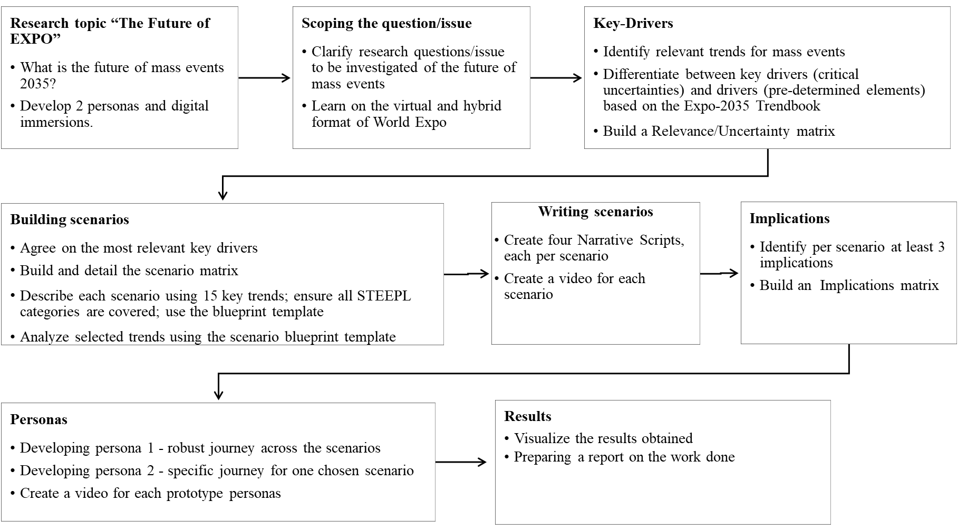
Picture 1 - Scenario Development Process within “The Future of EXPO” Project.

Digital tools for visualizing project results
When working on a project as a team, it is very convenient to use cloud technologies for collaboration. In this regard, we decided to develop a website on the Canva cloud platform (Picture 2). The advantage of this approach was that we adhered to one unified style of designing the results, we could all work together in one environment while preserving all changes made to the content. In addition, this platform allowed us to work with video content. As a result, we have a digital version of the project: the text part of the project, video clips of scripts, publication of the project in the cloud, access to which is provided via a direct link –
https://gftm-team.my.canva.site/dagp9nrfnwo/#about-team.

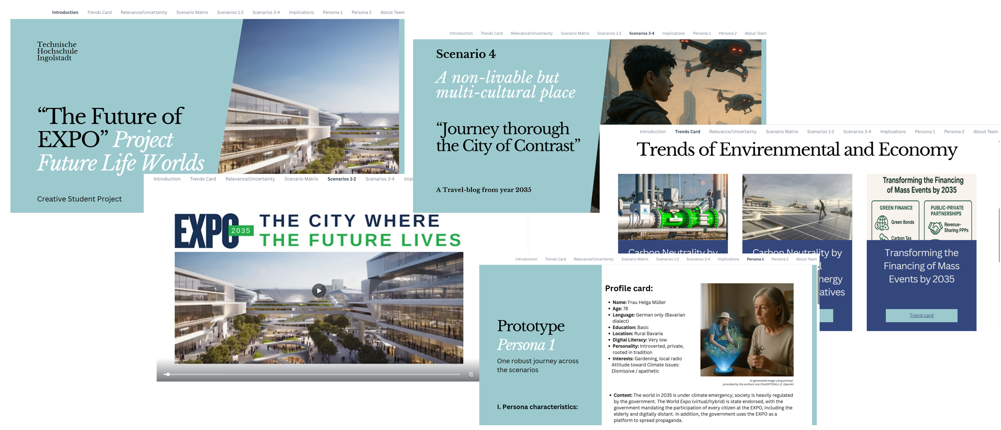
Picture 2 – Website “The Future of EXPO” Project.

2. Trend Analysis in the Development of Mass Events

Trend analysis is a cornerstone of strategic foresight, providing organizations with a framework to recognize, interpret, and respond proactively to patterns of change in areas such as technology, society, economy, and environment. As outlined in Strategic Foresight: An Introductory Guide to Practice by Prof. Jan Oliver Schwarz (2022), this process moves beyond reactive thinking and instead fosters anticipation and preparation for long-term developments.

For instance, tracking the steady rise of artificial intelligence or the demographic shift toward an aging population enables decision-makers to anticipate future societal needs. This proactive stance aligns with the principles emphasized by the Ellen MacArthur Foundation (2022), which advocates system thinking and circular models that adapt to long-term change. The foundation emphasizes that embedding such strategic foresight within policymaking ensures not only preparedness for the most probable future but also agility in the face of disruptive or less predictable scenarios.

When considering large-scale events like Expo 2035, trend analysis becomes indispensable for navigating uncertainty particularly in the economic and environmental domains. Economically, the transition to sustainable technologies, such as the decarbonization of steel production via hydrogen, reflects priorities highlighted by the International Energy Agency (2019), which discusses the potential of hydrogen as a transformative force in industrial applications.

Simultaneously, identifies such instruments as key to enabling long-term, impact-driven investment. These mechanisms are not only financial tools but also early indicators or "weak signals" of a broader shift toward collaborative, public-private governance structures prioritizing sustainable outcomes over short-term profits.

Environmental uncertainties, such as the escalating impacts of climate change, also necessitate resilient urban infrastructure. Practices like circular construction strategies, promoted by the Ellen MacArthur Foundation (2022), and localized energy systems like cooperatives, are no longer fringe innovations but part of a larger trend toward sustainability. The European Commission (2021) reinforces this trajectory through its support for smart urban agriculture and peer-to-peer energy trading both of which are critical for lowering emissions and improving food and energy security in urban contexts.

Informed by these insights, Expo 2035’s planning includes six selected future trends:
- Carbon Neutrality by 2045: Replacing Coal with Hydrogen in the Production of Steel
- Carbon Neutrality by 2045: Local Production of Energy Through Cooperatives
- Transforming the Financing of Mass Events by 2035
- Circular Economy at EXPO2035
- Agro - Future: Biotechnology for the Planet and Food Security
- Preparedness for Climate Change through Sustainable Urban Development

These trends, already visible in Germany and internationally, align closely with PESTEL analysis factors and are expected to contribute significantly to the sustainability, economic vitality, and technological legacy of Expo 2035.

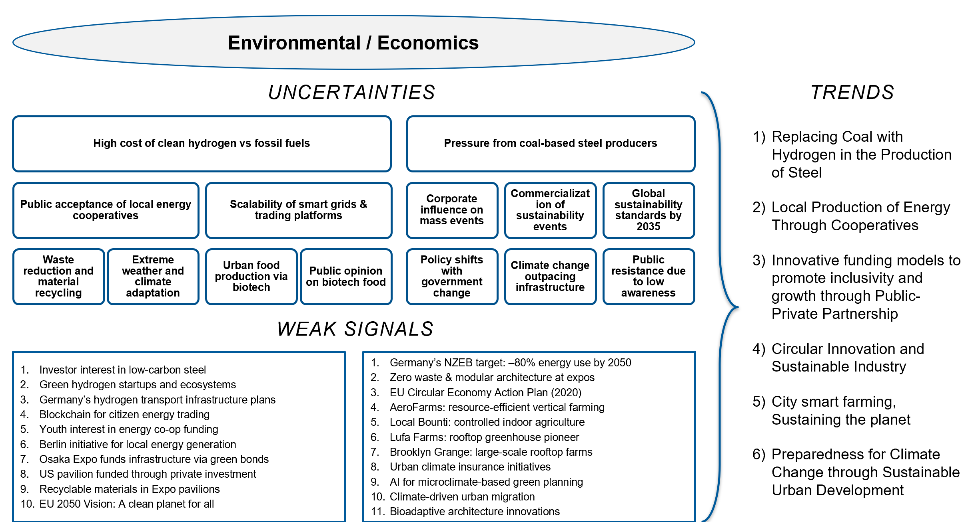
Picture 3 - The main uncertainties for “Environmental/Economics”

Table 2 - Key Trend Impacts for Expo 2035
Trend | Political/  Legal (P) | Economic (E) | Socio-cultural (S) | Technological (T) | Environmental (E) | Legal (L) | Impact Summary
Hydrogen in Steel Production (Carbon Neutrality by 2045) |  | ✓ |  | ✓ | ✓ | ✓ | Enables low-carbon Expo infrastructure, aligning with EU climate goals and boosting Germany’s green industry leadership.
Local Energy Cooperatives (Community-Driven Energy) |  | ✓ | ✓ | ✓ | ✓ |  | Reduces energy costs and carbon footprint while encouraging public participation and energy innovation.
Financing Mass Events with PPP & Green Bonds | ✓ | ✓ |  | ✓ |  | ✓ | More accessible and sustainable through inclusive, innovative funding models and long-term commercial use
Circular Economy for Expo Sites |  | ✓ |  | ✓ | ✓ |  | Minimizes waste and increases sponsor appeal by showcasing reusable, eco-designed pavilions and infrastructure
Urban Smart Agriculture (Biotech for Food Security) |  | ✓ | ✓ | ✓ | ✓ |  | Enhances food security and urban sustainability by integrating high-tech, climate-resilient agriculture.
Climate-Resilient Urban Planning | ✓ | ✓ | ✓ | ✓ | ✓ |  | Protects Expo infrastructure and public health by ensuring the site is adaptive to extreme weather and future climate risks

3. Assessment of Relevance and Uncertainty in the Future of Mass Events

In shaping the future of mass events, particularly looking ahead to platforms like Expo 2035, it is critical to evaluate emerging socio-technical transformations through the dual lens of relevance/impact and uncertainty.
The assessment framework maps key assumptions against key drivers, positioning each along a continuum of strategic relevance and future uncertainty. The key drivers are analyzed by describing the possible directions in which they could develop, including their polar outcomes. Trends may evolve in two possible directions. Two independent key drivers with the greatest relevance to the research questions are then selected. This method supports scenario development and helps prioritize focal areas for innovation and policy adaptation in the mass event landscape (Schwarz J. O. , 2023, p. 89).
The picture 4 shows the Relevance/uncertainty matrix in which the key assumptions and key drivers (in the upper right corner) are identified.

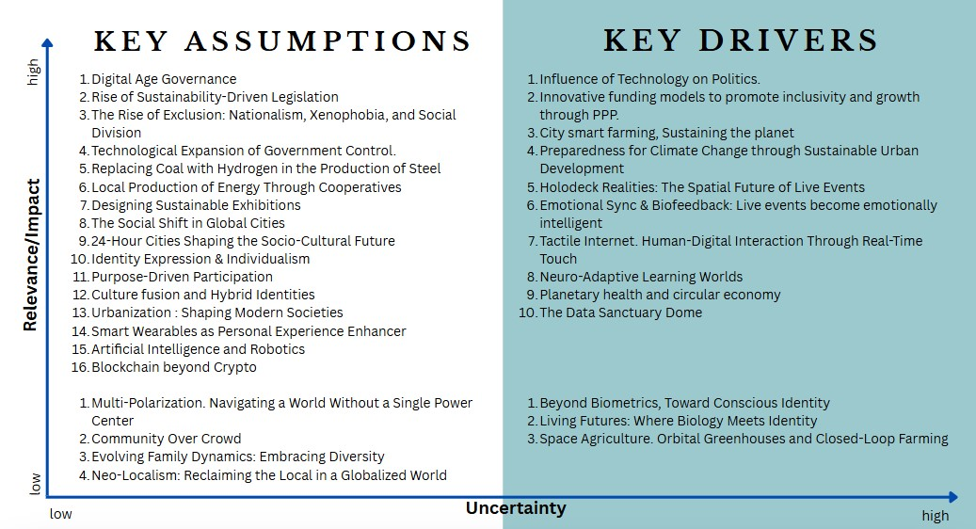
Picture 4 - Relevance/Uncertainty Matrix.

High Relevance, Low Uncertainty: Anchors for Future Planning
The upper-left quadrant in picture 4, includes assumptions with high relevance and lower uncertainty, representing trends that are already underway and expected to shape the event landscape with relative predictability. These include:
- Digital Age Governance.
- Rise of Sustainability-Driven Legislation.
- Designing Sustainable Exhibitions.
- Local Production of Energy through Cooperatives.
- Replacing Coal with Hydrogen in the Production of Steel.
These trends are essential building blocks for organizing inclusive, resilient, and ecologically sound mass events. They signify a maturing global emphasis on sustainability, decentralization, and technological governance that event organizers can confidently plan around.
High Relevance, High Uncertainty: Critical Uncertainties and Scenario Drivers
The most strategically significant insights emerge from Key Drivers with both high relevance and high uncertainty. These form the basis for future scenarios and stress-testing strategies. Some notable examples include:
- Emotional Sync & Biofeedback.
The potential to transform audience experiences through neuro-responsive environments adds emotional depth but raises ethical and infrastructural uncertainties.
- Tactile Internet & Neuro-Adaptive Learning Worlds.
Real-time digital-physical interfacing could redefine participation in live events but remains in experimental stages.
- Holodeck Realities.
Immersive event spaces could revolutionize spatial engagement, yet depend on speculative technologies and social readiness.
These drivers present opportunities for profound transformation in how mass events are designed, accessed, and experienced, especially within digital and hybrid formats.
Moderate/Low Relevance or Uncertainty: Peripheral Considerations
Some assumptions and drivers—while interesting—carry lower impact or higher unpredictability for the mass event domain:
- Space Agriculture, Neo-localism, and Biometric Identity Futures offer long-term speculative value but are less central to immediate event planning.
- Community Over Crowd and Evolving Family Dynamics are socially significant but only tangentially shape event design unless embedded through targeted programs.

4. Process of Scenario Planning for the Development of Mass Events

4.1. Key-drivers and their polar outcomes

Selection of Key Drivers
To begin the scenario planning process, all 33 previously identified trends from Trend-book Expo-2035 were evaluated by team members using a 1-5 scale for relevance (impact) and uncertainty regarding their influence on the future of mass events. The average scores for each trend were calculated, and based on these averages, trends were categorized into high/low relevance and high/low uncertainty.
We plotted these categorized trends onto a Relevance vs. Uncertainty matrix, allowing us to identify trends in the high uncertainty and high relevance quadrant as potential key drivers for scenario development.
From this quadrant, we selected two key drivers that are highly impactful, uncertain, mutually independent, and belong to different domains.
Choosing of Polar Outcomes
For the two selected key drivers, we defined two distinct polar outcomes as mentioned in Picture 5, for each, representing opposite futures along each axis:
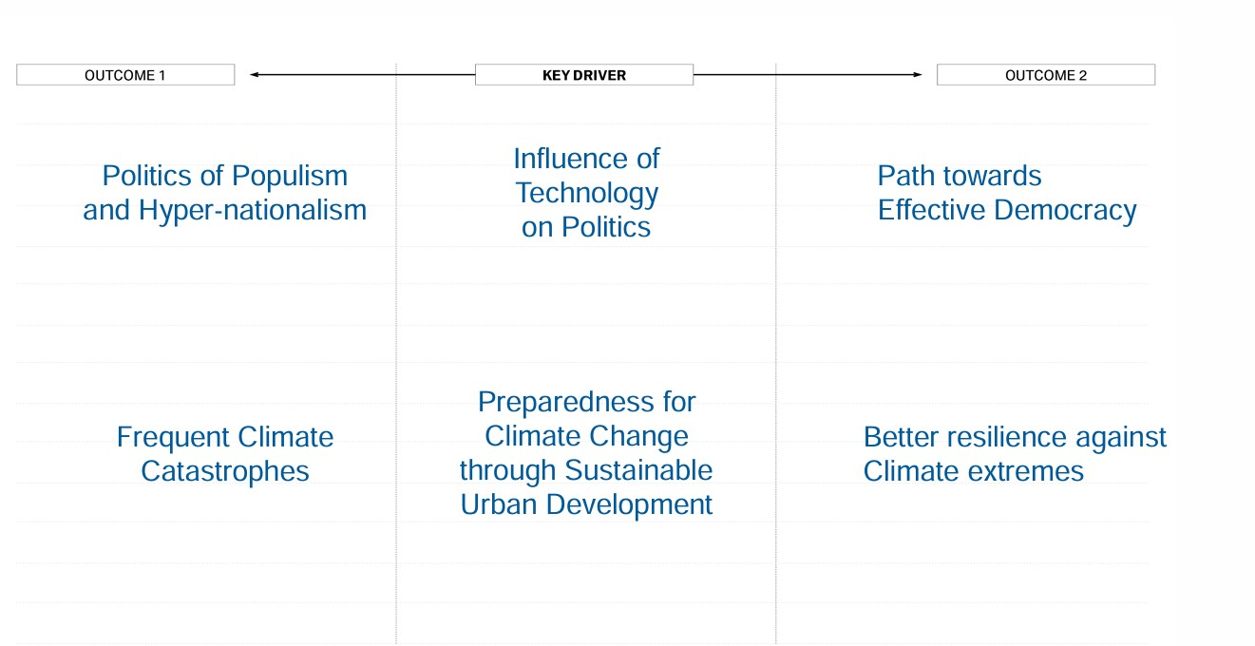
Picture 5 - Polar Outcomes of selected Key Drivers.

- Key Driver 1: Influence of Technology on Politics
  - Polar Outcome 1: Politics of Populism and Hyper-nationalism
In this future, technology is harnessed to consolidate power, manipulate public opinion, and promote exclusionary narratives. Governments use digital tools for surveillance, propaganda, and to stoke nationalist sentiment. Political discourse becomes polarized, and democratic institutions erode under populist influence.
  - Polar Outcome 2: Path Towards Effective Democracy
Here, technology empowers citizens and strengthens democratic processes. Digital platforms are used for transparency, civic engagement, participatory governance, and inclusive policy making. Trust between governments and citizens is high, and tech serves as a tool for collaboration and accountability.
- Key Driver 2: Preparedness for Climate Change through Sustainable Urban Development
  - Polar Outcome 1: Frequent Climate Catastrophes
This outcome envisions a future where climate adaptation efforts have failed or are insufficient. Urban infrastructure collapses under frequent environmental shocks such as floods, heatwaves, or storms. Migration rises, economies struggle, and societies are in constant recovery mode, facing both human and ecological crises.
  - Polar Outcome 2: Better Resilience Against Climate Extremes
In this future, cities and nations have invested in sustainable, adaptive infrastructure and planning. Green technologies, disaster-preparedness systems, and eco-centric urban design enable societies to withstand climate extremes. Mass events continue with climate-resilient formats and serve as platforms for global cooperation and innovation.

4.2. Scenario Matrix

The two key drivers and their polar outcomes were used to construct a 2x2 scenario matrix, producing four distinct future scenarios. Picture 6 shows the Scenario matrix with 4 distinct possible scenarios. Each scenario is also described with a few bullet points.
Scenario 1: A Livable and Multicultural Place
This future presents a world where societies have built strong resilience against climate extremes through sustainable urban development and inclusive governance. Effective democratic institutions thrive, supported by transparent, tech-enabled public systems that encourage citizen participation and accountability. Governments actively collaborate with communities to implement adaptive climate solutions, resulting in stable, secure, and livable environments.
Multiculturalism flourishes, with societies embracing diversity and openness. Climate resilience has enabled long-term planning, economic stability, and reduced inequality. Public trust in institutions is high, and cultural pluralism is seen as a strength in addressing both social and environmental challenges. This scenario embodies a balanced, cooperative world where both nature and society are valued and protected.

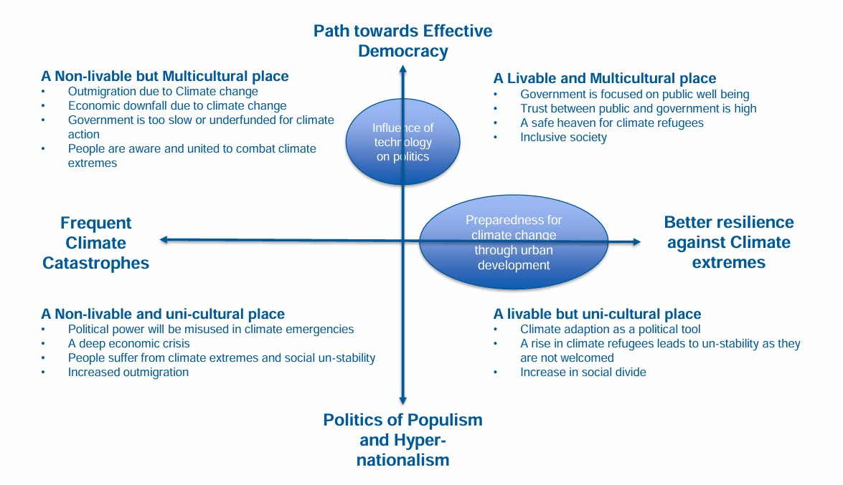
Picture 6 - Scenario Matrix.

Scenario 2: A Non-livable but Multicultural Place
In this scenario, democratic values and multiculturalism remain strong, but societies struggle with the escalating impact of climate catastrophes. Governments may be transparent and well-intentioned but are underfunded, fragmented, or too slow to respond effectively to environmental disasters. Despite social unity and civic awareness, the frequency and severity of climate events lead to economic collapse, infrastructure breakdown, and widespread displacement.
Communities remain inclusive and supportive, but resilience is low due to inadequate climate preparedness. People migrate from high-risk areas, and public services are stretched thin. The social fabric holds together in spirit, but daily life is marked by uncertainty, loss, and ongoing recovery efforts. This is a future where shared values persist, but environmental instability dominates human experience.
Scenario 3: A Livable but Uni-cultural Place
This world has successfully developed infrastructure and systems to resist climate extremes, but under authoritarian or hyper-nationalist regimes. Climate adaptation becomes a tool for political control, and while cities and economies are stable and secure, they operate within rigid, exclusionary social frameworks. Diversity is suppressed, and national identity is aggressively enforced.
While citizens enjoy physical safety and access to basic services, social freedoms are curtailed. Refugees and marginalized groups face discrimination, and cultural uniformity is promoted as a means of maintaining order. Climate policies are implemented efficiently but without equity or public voice. This scenario is defined by environmental stability achieved through social homogeneity and centralized power.
Scenario 4: A Non-livable and Uni-cultural Place
This is a fragmented, unstable world marked by authoritarian politics and environmental collapse. Governments exploit climate emergencies to tighten control, spreading fear and division. Societies are inward-looking, xenophobic, and distrustful, with rising inequality and social unrest. Infrastructure is weak, and public trust has eroded completely.
Frequent climate disasters strain already brittle systems, leading to mass displacement, deep economic crises, and deteriorating quality of life. Cultural diversity is suppressed, and the ruling powers prioritize control over resilience. Communities are isolated, and migration is met with hostility. This scenario is bleak, chaotic, and unsustainable - where both democracy and climate adaptation have failed.

4.3. Scenario Description with Scenario Blueprint
Making of Scenario Blueprint

To develop detailed, internally consistent worldviews for each scenario, we selected 15 trends - 2-4 each from five categories:
- Socio-cultural:
- Youth Culture: The Social Shift in Global Cities
- Identity Expression & Individualism
- Culture fusion and Hybrid Identities
- Technological:
- Smart Wearables as Personal Experience Enhancer
- Beyond Biometrics, Toward Conscious Identity: Adaptive Neuro-BioID and the Rise of Digital
- Artificial Intelligence and Robotics

- Economic:
- Local Production of Energy Through Cooperatives
- Innovative funding models to promote inclusivity and growth through Public-Private Partnership
- Circular Economy: A Living Lab for Circular Innovation and Sustainable Industry
- Environmental:
- Replacing Coal with Hydrogen in the Production of Steel
- Sustainable Bio-Economy: “City smart farming, Sustaining the planet”
- Political/ Legal:
- Rise of Sustainability-Driven Legislation
- The Rise of Exclusion: Nationalism, Xenophobia, and Social Division
- Multi-Polarization. Navigating a World Without a Single Power Center
- Technological Expansion of Government Control
Each trend was assessed for its relevance to each scenario on a 1-5 scale in Table 3 as a Scenario Blue-print. A brief description of how each trend manifests in each scenario was also provided. This gave each scenario a multidimensional character and ensured consistency across domains.
Table 3 - Scenario Blue-print
 |  | Scenario 1 |  | Scenario 2 |  | Scenario 3 |  | Scenario 4
 |  | A Livable and Multicultural place |  | A Livable but Uni-cultural place |  | A Non-livable and Uni-cultural place |  | A Non-livable but Multicultural place
 | Trend | Relevance | Description | Relevance | Description | Relevance | Description | Relevance | Description
ENVIRON-  MENTAL | Replacing Coal with Hydrogen in the Production of Steel | 5 | Public-private collaboration, skilled multicultural workforce, and trust in governance support large-scale transitions like hydrogen steel. Steel may even become a symbol of green urban growth. | 4 | The government is climate-resilient and may pursue hydrogen steel for economic and political gain (e.g., energy independence, job creation). However, nationalism may restrict international cooperation or hinder equitable tech access. | 1 | Economic collapse, political misuse of power, and climate instability make such capital-intensive projects unlikely. The steel sector may deteriorate or fall back on cheaper, dirtier methods. | 2 | While democratic intent exists, climate catastrophes and limited infrastructure hinder such transitions. The government may want to adopt hydrogen steel, but be too underfunded, slow, or reactive to implement it effectively.
 | Sustainable Bio-Economy: “City smart farming, Sustaining the planet” | 4 | In order to address climate adaption, the government promotes a sustainable bio-economy, but it ignores broad acceptance. | 4 | In order to address climate adaption, the government promotes a sustainable bio-economy, but it ignores broad acceptance. | 2 | Social divisions and financial instability are two factors that contribute to the lack of support for a sustainable bio-economy. | 4 | To improve resilience in the context of climate uncertainty, the government is implementing sustainable bioeconomy programs.
SOCIO-CULTURAL | Youth Culture: The Social Shift in Global Cities | 5 | Youth culture is becoming a driving force behind mass events, promoting the climate agenda, equality and dialogue between communities, in an atmosphere of trust in government and public. | 2 | Youth initiatives are allowed, but mass events are formed around a Uni-cultural model that emphasizes traditional values, which limits diversity and reinforces the perception of social divide among young people. | 2 | Amid social crisis youth culture is increasingly pushed to the margins and ignored, while mass events serve to reinforce official government ideology rather than represent the voices of the young. | 3 | In the face of climate change, migration and social un-stability, young people are using mass events as a way to express themselves, strengthen ties between cultures and create new forms of urban identity based on shared challenges.
 | Identity Expression & Individualism | 5 | Mass events become open spaces for self-expression, where people from different cultures and backgrounds can freely share their identities. | 1 | Mass events are organized under government control and support the ideals of national unity, while identity and cultural diversity are move to the background. | 1 | Mass events become tools of control and propaganda, while rising migration leads to tighter restrictions on cultural expression and public events. | 4 | Despite limited resources and ongoing economic crises, local initiatives support events that allow residents to express their identities, expression and development community networks.
 | Culture fusion and Hybrid Identities | 5 | Mass events actively support cultural fusion, where different communities create new hybrid identities through inclusive participation. | 2 | Mass events promote a Uni-cultural image, leaving little space for hybrid identities and intercultural dialogue. | 1 | Against a background of climate catastrophes and growing social instability, mass events no longer reflect cultural diversity: hybrid identities are erased, and more focus is placed on a uni-culture promoted by the government as a way to maintain control. | 3 | In the context of climate change, outmigration and unfavorable urban environments, mass events become a space for spontaneous interaction between cultures, where new hybrid identities are formed as a way of adaptation and mutual support.
TECHNO-  LOGICAL | Smart Wearables as Personal Experience Enhancer | 5 | These devices could be used for citizen engagement, real-time feedback to public services, and inclusive healthcare access. Multicultural openness encourages adoption of global tech trends. | 3 | While climate resilience ensures basic infrastructure for wearables, the populist political climate may restrict the kind of experiences wearables offer (e.g., surveillance, ideological filtering). | 1 | Social unrest, economic collapse, and environmental instability mean there’s low availability or affordability for such tech. Wearables might be used by a small elite or for state surveillance, but overall relevance is very low. | 2 | While democratic openness may encourage innovation and personal freedom, the ongoing climate crises and economic strain reduce focus and resources for wearable tech adoption. Wearables may be used for grassroots organization or health monitoring during crises.
 | Beyond Biometrics, Toward Conscious Identity: Adaptive Neuro-Bio-ID and the Rise of Digital  Entity Authentication in a Post-Human World | 5 | Conscious ID could enhance access to public services, secure digital voting, and personal data rights. Multicultural inclusion means systems must be fair, inclusive, and non-discriminatory. | 4 | In a hyper-nationalistic society, the technology may be used to enforce conformity or exclude non-dominant groups. Still relevant, but with possible ethical and civil liberty concerns. | 2 | While the authoritarian system might desire this tech for mass control and surveillance, the economic and infrastructural collapse limits rollout. Might exist only in elite or state-run institutions with authoritarian goals (e.g., refugee filtering, loyalty scoring). | 3 | Although the climate crises limit development, democratic values might still push for secure digital identities for climate refugees or aid distribution.
 | Artificial Intelligence and Robotics | 5 | AI and robotics are used ethically and inclusively for public good: smart governance, predictive climate management, universal access to services, elder care, and education. | 4 | AI is used effectively but potentially with ideological bias or surveillance objectives. Robotics aids climate resilience, but technologies may reinforce a mono-cultural narrative (e.g., restricted access, identity profiling). | 3 | AI may be weaponized or used for authoritarian control and Robotics deployed in limited, militarized or elite sectors. Widespread use is unlikely due to economic and infrastructure breakdown. | 3 | Despite economic and climate hardship, AI may be used in decentralized or community-based systems. Ethical frameworks and civic values promote responsible AI even if tech development is constrained.
ECO-NOMIC | Local Production of Energy Through Cooperatives | 5 | Mass events benefit from cleaner, cheaper, and more community-driven energy, enabling sustainable growth and broader regional participation without heavy regulatory pressure from the government. | 2 | Events remain reliant on traditional power sources, leading to higher costs and missed opportunities for local innovation and resilience, ultimately decelerating progress toward greater sustainability. | 1 | Energy systems become strained or unreliable due to climate-related disruptions (e.g., heatwaves, storms, blackouts), and without local alternatives, mass events face a higher risk of cancellations, increased operational costs, and/or failures. | 5 | Mass events become more community driven and resilient, as renewable energy sources such as wind and solar help events remain operational during blackouts caused by severe climate conditions.
 | Innovative funding models to promote inclusivity and growth through Public-Private Partnership | 5 | Mass events become more inclusive, accessible, and reflective of diverse communities, with fewer disruptions due to great climate conditions, leading to greater in-person engagement. | 4 | Mass events are not affected by environmental constraints. However, limited funding from private sectors and reduced innovation are a result of the government's prohibition of public-private partnerships. | 3 | Along with higher costs and reduced innovation, mass events are more likely to be canceled or moved to a purely online format due to unsafe conditions. | 5 | Mass events are sustained through adaptive infrastructure and innovation, but the success of these events depend on balancing climate resilience with equal access and inclusivity for all participants.
 | Circular Economy: A Living Lab for Circular Innovation and Sustainable Industry | 5 | Mass events become testing platforms for circular innovation solutions, showcasing sustainable practices to the public. | 3 | Circular innovation practices are used selectively at events to improve image, but true sustainability is limited. | 2 | Amid economic crises, climate extremes, and social un-stability, circular innovation solutions at events are replaced by quick, unsustainable alternatives; while rising out migration further loads urban infrastructure. | 5 | In response to climate change and growing outmigration, cities use local events as platforms for low-waste, circular innovation solutions that strengthen community ties and support inclusive society.
POLITICAL / LEGAL | Rise of Sustainability-Driven Legislation | 5 | Mass events evolve into reliable and eco-conscious gatherings, driven by innovation, minimal climate disruptions, and public trust fostered by transparent government sustainability efforts. | 5 | Despite occurring in climate healthy surroundings, mass events are likely to continue high-impact practices unchecked, leading to greater carbon footprint per event. | 5 | Mass events face safety risks and declining attendance, as government inaction on environmental laws accelerates infrastructure strain. | 5 | With sustainability laws in place, mass events in severe climate conditions will adapt through greener practices and climate resilient practices (e.g. flood-proof layouts), leading to safer, more efficient, and climate-conscious experiences.
 | The Rise of Exclusion: Nationalism, Xenophobia, and Social Division | 1 | Social trust and multicultural values counteract xenophobia, while the trend may exist globally, it holds minimal influence within this scenario. | 5 | Xenophobia fuels instability, especially with incoming climate refugees. The trend is central to the social structure here. | 5 | Social division and scapegoating likely intensify due to economic and climate crises. Outmigration, unrest, and authoritarian control fuel deeper exclusions. | 2 | While climate disaster destabilizes society, multiculturalism and democracy resist exclusion. Some social tension may arise, but collective unity and awareness mitigate the trend's impact.
 | Multi-Polarization. Navigating a World Without a Single Power Center | 4 | A democratic, open society thrives in a cooperative multipolar world, forming diverse global partnerships. Multi-polarization may reinforce inclusivity and decentralized resilience, but also demands skilled diplomacy. | 5 | Multi-polarization plays directly into populist politics: national pride, selective alliances, and climate cooperation as geopolitical leverage. Countries may resist international pressure on immigration or rights, but align economically on climate tech. | 3 | In this breakdown scenario, multipolarity may intensify global fragmentation, making coordinated aid and climate response more difficult. The scenario may arise partly due to failed cooperation and competing powers exploiting crises. | 4 | A decentralized world order may offer lifelines through regional alliances, diaspora networks, and civil coalitions. This society could use multipolarity to access aid, advocate for climate justice, or empower grassroots diplomacy.
 | Technological Expansion of Government Control | 5 | Technologies are used transparently, helping to organize mass events with the participation of citizens and respect for rights, strengthening trust between the public and the government. | 2 | Technology increases control over mass events, allowing for the promotion of a Uni-cultural line and the filtering of undesirable forms of expression. | 2 | In the context of climate catastrophes, mass outmigration and deep economic crises, mass events are strictly controlled through digital surveillance, turning into controlled rituals that exclude any form of dissent. | 3 | Technology is used to coordinate and control mass events in the face of increasing climate change and rising migrant numbers, but due to a lack of trust in government, it is perceived as a means of repression rather than protection.

5. Development of Detailed Scenarios

5.1. About Scenario Development Process

Scenario planning is one of the tools of strategic foresight. Scenarios are used to create awareness and prepare for an uncertain future (K. Cordova-Pozo and E.A.J.A. Rouwette, 2023).
In a literature review by K. Cordova-Pozo and E.A.J.A. Rouwette (2023), based on an analysis of definitions presented in 13 other reviews, the authors found that the most frequently occurring elements include the following: scenarios are a set of narratives describing different alternative futures, constructed with an iterative approach based on the uncertainties of the context, with the aim to raise awareness of plausible futures and increase performance of the organization.
Professor Schwarz notes in his book (Schwarz, J.O. 2023) that key aspects of scenario planning are that it is highly participatory and challenges the assumptions of those involved in the process and in creating memories of the future.
In general, what does a scenario (describing a plausible future) consist of (K. Cordova-Pozo and E.A.J.A. Rouwette, 2023):
- scenario purview (the orientation to the future and external context);
- narrative description (should appear as plausibly possible);
- uncertainty (as a key factor in exploring different future worlds);
- variability of scenarios (intentionally different to present different versions of the future).
Table 4 provides an overview of scenario narratives we developed, with a description of the attributes.
The following subsections present four contrasting scenarios, each describing possible future worlds. These scenarios are considered in the context of climate change, technological developments, urbanization, and culture, suggesting different social, environmental, and cultural options that we may face.

Table 4 - Overview of Scenario Narratives
Attributes | Scenarios
Name | A Livable and Multicultural place | A Livable but Uni-cultural place | A Non-livable and Uni-cultural place | A non-livable but multicultural place
Scenario purview | The orientation to the future | The orientation to the future | The orientation to the future | The orientation to the future
Narrative Type | Newspaper article | Newspaper article | Newspaper article | Travel Blog
Name story | “The City Where  the Future Lives” | “Everything’s  Different - But  Somehow the Same” | “How One Rainstorm  Exposed the Cracks in  Our City’s Soul” | “Journey thorough  the City of Contrast”
Scenario Event | EXPO | Film Festival | Birthday in the Ruins | Journey
Event Timing | 2035 | 2035 | 2035 | 2035
Conclusion | The scenario “A Livable and Multicultural Place” shows a future city as a lively, sustainable, and inclusive system. Technology is a natural part of daily life, and cultural diversity is not only accepted but becomes a base for new ideas and communication. In this world, citizen participation, open government, care for the climate, and digital tools work together to create a safe, open, and inspiring city environment. | The scenario “A Livable but Uni-Cultural Place” shows a future city that is clean, well-organized, and looks sustainable. Technology and culture work together smoothly - but this happens by losing diversity and depth. Behind the image of progress, everything becomes the same. There is no space for disagreement or complexity. The system gives people comfort and safety, but removes anything that doesn’t fit. Real culture turns into something repeated and controlled. | The scenario “A Non-Livable and Uni-Cultural Place” shows a dark picture of a city where outside order hides deep problems and loss of meaning. Behind the clean image are broken systems, controlled culture, strict technology, and one way of thinking that removes difference and freedom. This world cannot protect people - not from real storms, and not from fear, isolation, and the loss of hope for a fair and living future. | The scenario “A Non-Livable but Multicultural Place” shows a future city that is full of problems, but still alive. Chaos lives next to solidarity, and weakness comes with creative strength. Even with climate problems, control through technology, and a lack of resources, diversity continues to grow - through street festivals, local projects, shared energy systems, and cultural cooperation. This is not a utopia, and not a ruin - it is a city learning how to stay together.
Storytelling Tools | The scenario narratives were generated with the help of the ChatGPT language model (OpenAI), based on the authors’ prompts and editorial guidance.
Visualization Format | The videos created for each scenario  are published on the website (https://gftm-team.my.canva.site/dagp9nrfnwo/#main ) (Scenarios 1-2, Scenarios 3-4)
Image & Video Tool | AI-generated image using prompt provided by the authors (via ChatGPT/DALL·E, OpenAI),  video rendering by RunwayML, FLIKI, Invideo and AI Voice by Canva

5.2. Narrative Script: Scenario 1

“The City Where the Future Lives”
You don’t quite notice the entrance - the flow just carries you in. One step, and you're inside a place where every sound, every movement is part of a larger rhythm. Sidewalks collect energy from your steps. Solar canopies soften the light above. Teenagers nearby debate the next panel on digital rights.
This is more than an EXPO - it’s a working model of a city ready for climate challenges. A sustainable, multicultural, and dynamic metropolis where green walkways connect pavilions with homes, drones guide without policing, and screens broadcast debates on AI, migration, and urban ethics.
What struck me most wasn’t the technology - it was the atmosphere (picture 7). Youth weren’t just participants - they led. Their projects turned pavilions into dialogue spaces, where listening mattered more than showcasing.
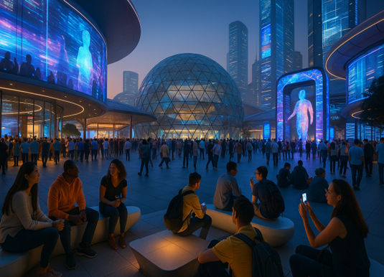
Picture 7 - Visualization of Scenario 1 fragment

The hybrid cultural projects were especially memorable: Arabic calligraphy layered over Spanish-language poetry, African drumming fused with Nordic electronic beats. It wasn’t just integration - it was real cultural fusion, without the need to simplify or smooth out the differences.
“We built EXPO as a civic space - where innovation happens through people and shared action,” said one of the organizers.
Everything you once associated with progress isn’t behind glass here. No one showcases technology - it’s folded into your route, your voice, your breath. In this city, drones don’t patrol - they guide. And there are no loudspeakers. Only phrases shared in quiet:
“You feel like you don’t need to explain who you are. This place already knows.”
And the tech? Not about spectacle. And to shape the path of urban development - making city life safer and more humane. A man in line for coffee showed me how his smart wearable devices automatically adjust his public transit routes, provide seamless access to digital services, and - most impressively - offer real-time translation when communicating with tourists or new neighbors. In a multicultural society like this, such technologies aren’t just trendy - they’re a vital bridge between people.
The most surprising thing for me was the identification system. It used not only fingerprints or face scans, but also how people act and think. With this system, people could vote, go to the doctor, or share data - all without feeling watched. Here, technology doesn’t make people nervous - it makes them feel safe. AI doesn’t govern from above - it supports, walks besides, and adapts to people.
Energy isn’t produced somewhere far away - it’s generated right in the city: through rooftops, sidewalks, even human movement. Each pavilion runs on energy from local cooperatives, and citizens can trace every kilowatt. Energy here is not a commodity - it’s a shared responsibility.
The financial system works the same way. Urban projects are funded through microfinancing, digital grants, and collective investments. Businesses, city authorities, and residents act as partners - not opponents.
In experimental zones, students and engineers test architecture that can be assembled and disassembled like building blocks. Structures are made from recycled materials, food is prepared with zero waste, and the entire system runs on low-emission principles. It’s not just a demonstration, it's a rehearsal for sustainable city life.
Even heavy industry is evolving. One plant has replaced coal with hydrogen. But the real shift isn’t just technical - it’s social. The production site has become a place of connection: engineers, migrants, and city workers come together. What they’re building isn’t just steel - it’s a new urban culture.
One greenhouse pavilion, powered by solar and hydrogen, grows food, recycles resources, and runs real tests for the city’s bio-economy. It’s operational, not experimental.
“The technology works. The real challenge is making it feel like everyday life,” one curator admitted.
Here, laws aren’t written behind closed doors - they emerge through civic dialogue. Climate contracts, digital voting, open data - it’s governance from the ground up.
Technology supports participation, not surveillance. Public trust is built not by control, but by transparency and respect.
In this multicultural city, sustainability is built on respect for diversity. People vote in many languages, and climate is approached through lived experiences - not abstract slogans.
Mass events here aren’t just celebrations. They’re exercises in resilience: low-emission, zero-waste, and rooted in citizen participation.
And perhaps that’s the city’s real innovation. Not perfection - but a daily invitation to be part of something shared. A city that doesn’t wait for the future. It lives it - with care, with complexity, with everyone.
By our correspondent on site
DER SPIEGEL, May 27, 2035

5.3. Narrative Script: Scenario 2

“Everything’s Different - But Somehow the Same”
I went to the Film festival – 2035.
At first, I couldn’t figure out what felt wrong.
Everything around me was stunning. The city glowed with precision. Smart stops, AI-curated coffee blends, silent shuttles that arrive the second you finish typing a message.
The film festival? Flawlessly run. Smart wristbands guided you through the schedule. Your seat adjusted based on your biometric data. Even the sound adapted to your emotional profile. No crowds. No confusion. No technical hiccups. This was the future.
But after the third film in a row, I realized: I felt nothing. No anger. No inspiration. No spark. Just... quiet (picture 8).
“All the films looked different, but they all said the same thing,” said the guy next to me. And he was right.
Each film tackled “important” themes - sustainable fashion, collective solidarity, digital justice. Every topic was correct. Every production, flawless. But if you closed your eyes and ignored the credits, you couldn’t tell one director from another. It was like they all had the same curator. Or editor. Or fear - of stepping outside the frame.
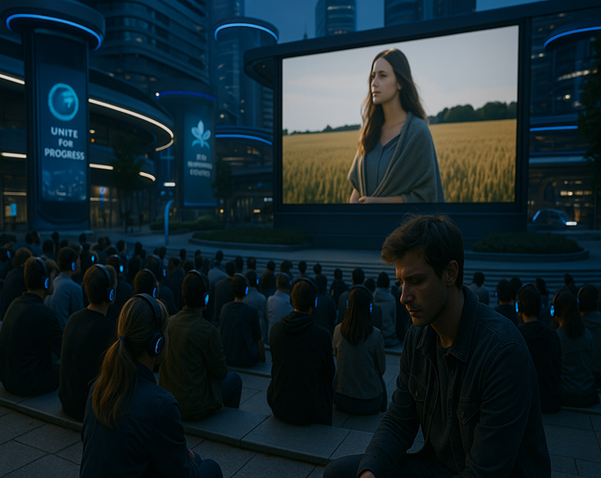
Picture 8 - Visualization of Scenario 2 fragment

We’re living in a uni-culture. Officially, there’s no censorship. Nobody tells you what you can’t say. But the system is built in a way that anything different never gets through. Anything that feels off-rhythm, out-of-tone, unapproved - doesn’t pass. The algorithm doesn’t recommend it. The committee doesn’t select it. The platform doesn’t see it.
Culture works like GPS now. Straight lines only. No wrong turns.
I remember when culture used to argue. It made mistakes. It shouted. Now it explains. It is reassuring. And more than anything, it repeats. The curator says what the speaker says. The speaker says what’s on the banner. The banner says what the city’s official channel already posted that morning.
We call it “resilience.” But it feels like uniformity. Polished harmony, where nothing breaks the frame.
The younger generation? They’re brilliant. Thoughtful. Green. But I rarely hear doubt. No one wants to “break the system” - because the system is embedded in their scholarships, their portfolios, their invitations to city-run programs. Self-expression has become a form of loyalty.
“We’ve gone too far into compatibility,” a young curator told me. “It used to be enough to be interesting. Now you have to be aligned.”
And beyond culture, the city wears a mask of progress. Clean. Calm. Controlled. But dig deeper, and contradictions surface. Mass events boast of clean energy, but still run on old systems. Local energy collectives? Never got scaled. The private sector? Shut out in favor of total municipal control. No partnerships, no entrepreneurial chaos - just predictable, public prototypes. Yes, there are circular elements: recycled materials, green slogans, compostable cups. But much of it serves the image, not the system. As with culture, there’s a polished form - and there’s what it quietly hides.
And the silence? It’s louder than anything. Migrants, especially those displaced by climate change, are vanishing from view. Their stories aren’t told. Their languages aren’t heard. Participation is technically open - but practically absent. We showcase green leadership, international cooperation, and climate resilience. But when it comes to migration, dissent, or pluralism - silence. A curated silence that filters who gets seen, heard, celebrated. National pride becomes a sorting mechanism: who fits the story, and who quietly disappears from it.
Yes, this city works. It’s beautiful. Functional. Livable. But it has deleted everything uncertain. Everything is messy. Everything is truly alive.
And I keep wondering:
What if ten years from now we wake up and realize - we had everything… except ourselves?
An honest column by someone
still searching for meaning in a perfect city.

5.4. Narrative Script: Scenario 3

“Birthday in the Ruins: How One Rainstorm Exposed the Cracks in Our City’s Soul”

Today was supposed to be different. It was my birthday. I had planned a small family dinner in Old Centrum - nothing lavish, just a meal under the stars, a moment of peace in this city of sirens.
But as we stepped outside, the rain came down like a warning, heavy, unrelenting, and cruel. Within 30 minutes, the streets were flooded. The tram network collapsed. Power outages rolled across the districts. Food delivery drones rerouted and vanished mid-air. Emergency lines were jammed. And once again, the city failed - not just its infrastructure, but its people.
And I sat there - wet, tired, angry - not just because my birthday plans were ruined, but because this storm felt like the perfect metaphor for our times.
A City of Ruins Beneath a Facade of Order
This isn’t about one rainstorm. It’s about a system corroded by denial, held together by propaganda, and ruled by fear. Let’s talk plainly.
Youth culture? Silenced.
Once a vibrant force in this city, the youth are now either unemployed or drafted into state programs. Their events - once spaces of creativity and connection - have turned into ideological performances scripted by the state. There's no room for dissent, no celebration of difference.
Identity expression? Criminalized.
In a time when migration is rising due to our worsening climate, our leaders have responded not with empathy, but restrictions (picture 9). Hybrid identities and multicultural expressions are dismissed as “destabilizing.” Events must now pass through ideological review.
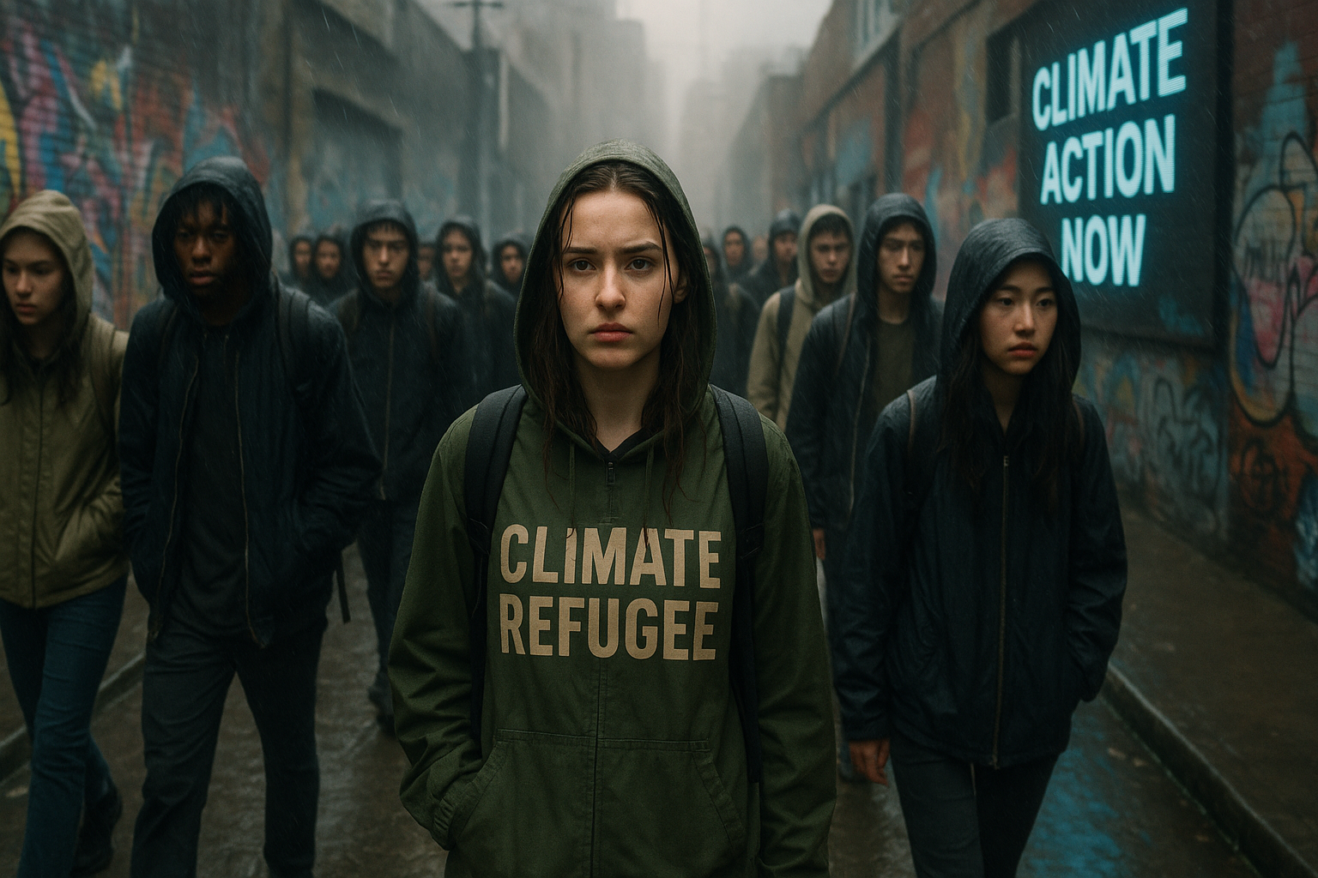
Picture 9 - Visualization of Scenario 3 fragment

Tech Dystopia in Disrepair
Some still wear smart patches and neuro-ID bands, but don’t let that fool you. These aren’t tools of progress - they're badges of privilege and control. The state uses them to track loyalty, filter aid, and scan for dissent.
As for AI? Forget any utopian dreams. Most of it’s locked in military zones or used for digital policing. The public has neither access nor trust.
Economy of Desperation
Remember when we once dreamed of solar cooperatives and green infrastructure? Today, we depend on outdated grids that fail at the first sign of thunder. Local events are either canceled or moved online - if the networks are even working.
Public-private partnerships have collapsed under rising costs and corruption. The circular economy is a concept we discuss in history books now. We rely on disposable fixes, not sustainable solutions.
The Green Mirage
Our leaders talk green, but the reality is coal is back, and dirty industries rule the outskirts. Talk of hydrogen steel is laughable. City farming projects have either failed or turned into elite ventures, inaccessible to the average citizen.
The few sustainability-driven laws passed last year have been mostly symbolic, underfunded, or unenforced.
Division is the Only Constant
What hurts the most is the division.
Nationalist rhetoric fills our feeds. Climate refugees are blamed for everything - from job scarcity to disease outbreaks. Neighborhoods that once brimmed with cultural exchange now sit in silence, patrolled and monitored.
Globally, things are no better. The multipolar world has splintered into factions. Aid is no longer coordinated - it’s weaponized. We’re caught between indifferent alliances and opportunistic rivals.
And at home, the final layer: control through tech. Public-events have become stage-managed rituals. Every camera is watching. Every attendee is counted. Spontaneity has been deleted.
No Shelter in the Storm
So yes, today’s rainstorm was a disaster.
But it wasn’t just water that poured over this city.
It was a flood of truths we’ve long tried to ignore:
- That we are not resilient.
- That our diversity is being erased.
- That our tech, our laws, our economy - have all been captured by fear.
And I’m tired.
Not just of being wet, or missing dinner.
But of celebrating another year in a city that punishes those who dream differently.
Final Word
Some will read this and call me bitter. Others might dismiss it as "sentimental journalism."
But maybe - just maybe - someone will read this and remember who we were supposed to be.
Before the floods.
Before the fences.
Before the silence.
By: Peter Parker, Senior Journalist
The Gotham Times
July 3, 2035

5.5. Narrative Script: Scenario 4

"Journey through the City of Contrast"

I’ve heard whispers - some call it “The Last Beacon of Urban Multiculturalism”, others scoff and say “A Melting Pot on the Edge of Collapse.” I couldn’t resist. I packed my modular bag, charged my solar drone, and flew into the heart of New Harmonia, a coastal city-state rebuilt by climate survivors, artists, technocrats, and urban refugees.
The media couldn't make up its mind about this place. But I’ve never trusted filtered pixels. I wanted to see it, feel it, live it - the contradictions, the culture, the climate, the chaos.
First Impressions: A City Breathing Through Cracks
The air was hot - scorching and uneven, like the climate couldn’t make up its mind either. Flash flood barriers towered at intersections. Solar sails flapped above open markets. And right at the arrival terminal, a group of young artists was organizing what they called a “Resilience Jam” - a mass event blending protest, performance, and poetry, where every voice found rhythm.
I asked a young organizer named Leena what the point was. She smiled, “We’ve lost homes, we’ve lost hope. But we’ve found each other.”
Identity Everywhere, Yet Nowhere
From food stalls run by Ethiopian-Korean chefs to murals quoting indigenous wisdom in four languages, the fusion of identities was overwhelming, yet organic. You’d think resource scarcity would kill self-expression, but no - local councils actually fund micro-events that celebrate personal stories and cultural heritage.
On 9th Avenue, I attended a “Mirror Night” - a block party where people wore clothes representing both their past and future selves.
The clothes were upcycled, the lights were pedal-powered, and the vibe was pure defiance.
Tech: Power to the People… Mostly
Technology here is a paradox. Smart wearables are everywhere, but not as luxury gadgets. They’re DIY-printed health patches, crowd-safety alerts, and even environmental sensors warning of incoming dust storms.
Yet, everyone side-eyes the government drones overhead. They fly above every large gathering, claiming to “ensure climate safety.” People whisper of biometric scans gone wrong and data sold to external powers.
It’s a democracy, sure - but trust is thin.
Power from the Crowd, Literally
I visited an abandoned stadium, now reborn as the "Solar Circle", a community-run venue for everything from film nights to disaster shelters. It runs entirely on community-owned wind and solar grids, and uses circular economy practices for waste and energy.
During a sudden blackout across the commercial district, the Circle was still glowing, still alive. People gathered like moths to firelight - safe, connected, empowered.
Money and Morality
One part of the city struck me deeply - Green Lot, where mass events only happen through inclusive public-private funding models. The stage was made from reclaimed wood; the lights ran on kinetic floor panels.
But the border of the lot told a different story. Those outside the digital ID system - stateless migrants, recent climate escapees - were locked out, sometimes quite literally. A volunteer told me, “We're inclusive… until we’re not.”
Concrete Meets Green Dreams
Even amid decay, there are signs of regeneration. Rooftop aquaponics feed dozens of homes. Kids learn soil-less farming in former shopping malls.
Despite major policy hurdles and budget shortfalls, the government is trying. Sustainability laws require every new event space to be climate-proof: elevated stages, heat shelters, water catchments.
Steel production? Still coal-heavy. Hydrogen dreams exist, but they’re dreams. Too expensive. Too delayed.
Diplomacy of the Displaced
Strangely enough, New Harmonia survives not because of a single strong leader, but because of coalitions, diasporas, and alliances with other decentralized cities. Aid comes from everywhere and nowhere. Deals are made through encrypted diplomatic circles.
This web of interdependence gives it strange resilience. Like a spider on a cracked window - fragile, but persistent (picture 10).
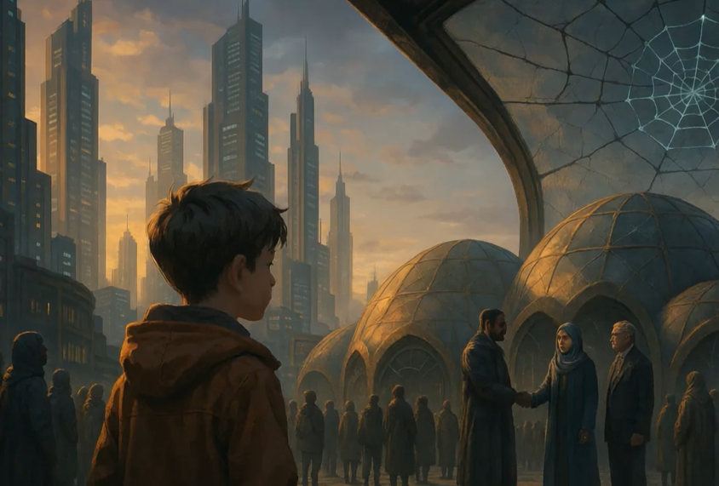
Picture10 - Visualization of Scenario 4 fragment

My Final Note
New Harmonia is not a utopia.
It is humid, noisy, underfunded, and in parts unlivable. But it is also multicultural, expressive, and fiercely democratic. Its people are more united than happy, more tired than free, but in them I saw hope as a survival instinct, not a luxury.
Media got it wrong.
This isn’t a city falling apart.
It’s a city learning to hold itself together.
Next Stop: Cairo Delta Arcology
Let’s see how it compares...
"City of Contrast – My 2035 Journey Through New Harmonia"
By: Nomad 2050, July 3, 2035

6. Evaluating the implications of implementing EXPO 2035 under different scenarios

6.1. The Implications Matrix

After going through all the situations and scenarios, we draw on the implications of the scenarios. We look at the most probable implications which can be associated with all the different scenarios and grading them according to the relevance. The scores, as we have put, are based on our understanding of the implications. We have put twelve of them and graded them to know which ones are more specific and which are robust ones. The details are given in the following table 5 (description: Scenario 1 - A Livable and Multicultural place; Scenario 2 - A livable but Uni-cultural place; Scenario 3 - A Non-livable and uni-cultural place; Scenario 4 - Non-livable but Multicultural place).

Table 5 - Implications Matrix
 | Implications | Scenario 1 | Scenario 2 | Scenario 3 | Scenario 4 | Score
1 | The interactive and social function of the exhibition space will play an important role in making visitors more engaged. Description: In the future, exhibition spaces will not only show things — they will become places where people can talk, share, and take part. Visitors will not just watch; they will join the activities and help create the experience. | 5 | 3 | 0 | 3 | 13
2 | Digital environments will become proactive, supportive and more intuitive for visitors. Description: Future digital environments and AI systems will not just be navigators, but adaptive assistants that can understand the context, take into account the emotional state, language, cultural background and interests of the visitor. They will not impose, but unobtrusively accompany, offering personalized routes and engaging experiences, making large-scale events more human and accessible to everyone. | 5 | 5 | 3 | 3 | 16
3 | The pavilions act as prototypes of sustainable urban infrastructure. Description: These spaces act as functional models of the future city – with renewable energy, circular materials and digital solutions based on citizen participation. They do not simply showcase ideas, but undergo real-life viability tests. After the exhibition, they can be deployed in real cities as practical pieces of future infrastructure, turning EXPO into a tool for long-term urban transformation. | 5 | 5 | 0 | 0 | 10
4 | Civic participation will become highly curated through algorithms. Description: Even in digital and open environments, citizen participation will increasingly be filtered by algorithms – through recommendations, moderation, and selection of visible content. This creates the appearance of inclusivity, but can exclude controversial and unconventional voices. The EXPO of the future must seek a balance between manageability and genuine diversity, so that algorithms do not simplify reality, but support the participation of a wide range of groups. | 0 | 5 | 5 | 0 | 10
5 | Visible sustainability hides invisible inequalities. Description: Impressive visual sustainability – green technologies, clean spaces, smart solutions – can create a façade of progress that hides social imbalances. When sustainability becomes decoration, the voices of vulnerable and disadvantaged groups can be marginalized. The EXPO of the future must strive not only for external displays of sustainability, but also for deep social inclusion. | 1 | 5 | 5 | 1 | 12
6 | Cultural expression may be muted by systemic alignment pressures. Description: In an environment where everything is strictly organized, cultural expression can become monotonous and safe, rather than vibrant and diverse. When only projects that fit the “official tone” receive support and attention, artists and authors begin to repeat themselves and avoid risks. The EXPO of the future must create space for different voices, debate and experimentation, otherwise creativity will become a form of submission. | 0 | 5 | 5 | 0 | 10
7 | Loss of Global Credibility & Participation: International boycotts or withdrawals may occur due to the host country’s authoritarianism, nationalism, and exclusionary policies. Global institutions and multicultural delegations may hesitate to associate with a regime known for human rights suppression and climate negligence. | 0 | 5 | 5 | 0 | 10
8 | Security-Driven, Heavily Policed Event: Due to deep social unrest and climate-related instability, the expo would be under intense surveillance, with limited freedom for visitors. Public spaces and pavilions would likely be controlled rituals, promoting state ideology rather than authentic cultural exchange. | 0 | 5 | 5 | 3 | 13
9 | Infrastructure Failures and Disruptions: Climate catastrophes—such as flash floods, heatwaves, and power outages—would jeopardize the continuity and safety of the expo. Emergency evacuations, blackouts, or collapsed supply chains could disrupt the visitor experience. | 0 | 0 | 5 | 5 | 10
10 | Expo as a Space of Resistance and Solidarity: Despite infrastructure challenges, the expo becomes a platform for inclusion, unity, and resilience. Civil society groups, refugee artists, and multicultural communities could use Expo to voice collective concerns and inspire global solidarity. | 5 | 1 | 1 | 5 | 12
11 | Themes of Climate Justice and Adaptation: The core themes of the expo would shift toward climate resilience, disaster adaptation, community innovation, and sustainability. Expect low-budget but high-impact, community-led innovations—like circular economy models, refugee-designed pavilions, and grassroots tech. | 5 | 3 | 0 | 2 | 10
12 | Underfunded but Authentically Vibrant: Economic downturn would result in modest installations, but rich cultural diversity and open dialogue would make it a meaningful experience. Hybrid identities and fusion cultures would be celebrated, giving Expo a dynamic and deeply human flavor. | 3 | 0 | 2 | 5 | 10
 | Score | 29 | 42 | 36 | 27

6.2. Conclusion derived on the basis of assessment

In our study, it was found that the robust implication is Digital environments will become proactive, supportive and more intuitive for visitors. This implication covered all our scenarios as we assumed that in all likelihood, whether it is a sustainable or a fragile infrastructure, or it is flexible or rigid government or society, the mass events will have their core features associated mainly with digital environments, looking at the current digital technology revolution.

7. Developing personas showcasing an immersive participants’ journey

One of the central challenges in foresight is making possible scenarios and futures tangible, relatable, and emotionally resonant (Candy & Dunagan, 2017). To address this, the integration of personas has emerged as a valuable method for enriching scenario-building processes and fostering a deeper understanding of the futures being explored. While these fictional, evidence-informed representations of stakeholders are commonly used in product and service design to capture current user needs, they also offer significant potential to humanize and deepen foresight work. Specifically, personas enhance the creative imagination of individuals involved in scenario-building by allowing them to envision alternative futures through the perspectives of these fictional characters. Additionally, personas improve the communication of complex scenarios by making them more relatable and support sensemaking by grounding abstract changes in familiar life experiences (Schwarz et al., 2025).
The effectiveness of personas in foresight, however, relies heavily on their intentional design and careful selection. Like any approach, personas come with inherent limitations, particularly when biases arise from relying on present-day assumptions and data. This can unintentionally narrow the scope of future scenarios (Schwarz et al., 2025). A key method to address this issue is by creating multiple personas, each representing a diverse range of user types, backgrounds, needs, and desires. This strategy ensures a broader perspective on future scenarios, helping to mitigate potential biases (Fergnani, 2019) and enabling participants to explore how different individuals might engage with emerging futures. Crucially, personas can also help uncover normative assumptions and expose power dynamics often implicit in scenario-building exercises (Rutting et al., 2024)( Mangnus et al., 2021). Therefore, the guiding question is not only how to use personas, but also which personas to use - and why.
In light of this, the chapter will introduce and examine the characteristics of two contrasting personas: one, a young, tech-savvy individual from an urban area in Germany, who is likely to be more engaged with future events such as EXPO 2035, and another, an older persona, living a more traditional lifestyle in rural Germany, who mostly uses technology out of necessity. The chapter will delve into their attributes, knowledge, and preferences, as well as the rationale behind their selection for the scenarios presented. Their immersive journeys will also be explored, highlighting key stages, emotional highs and lows, touchpoints, and inner thoughts that will further humanize their experience.

7.1. Overview of the Personas

Frau Helga Müller – persona 1
In a small village in rural Bavaria, Frau Helga Müller, aged 78, lives a quiet, routine life shaped by decades of traditional living, despite being in the year 2035, a time marked by severe climate instability and heightened government control (picture 11). Her life remains grounded in analog routines, tending to her herb garden, drying flowers, and listening to local radio in her native Bavarian dialect. Although she owns a smartphone, her digital literacy is limited; she uses it only when necessary, and often with frustration. Helga completed only basic formal education and has never felt at ease with technology. She is introverted, private, and rooted in tradition; Qualities that make her skeptical of government initiatives, especially those cloaked in digital formats. As the state mandates citizen participation in a government-endorsed virtual World EXPO, Helga complies, not out of belief, but obligation. She feels distant from climate narratives, viewing them as abstract or politicized, despite their visible impacts on her once-thriving garden.

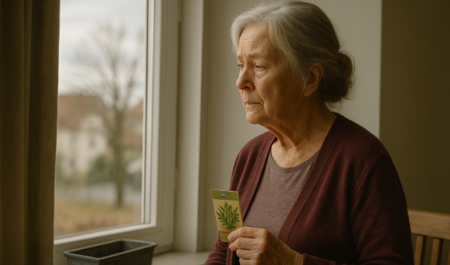
Picture 11 - Persona 1

Helga has been selected as a central persona precisely due to the fact that she embodies the often-overlooked edge of digital futures: the rural, the aging, and the linguistically isolated. Her daily life is rooted in tactile, analog routines, and she does not naturally or easily engage with digital tools or platforms. As a result, she does not actively use or benefit from technology - she endures it because she must. Including Helga in foresight challenges common assumptions that all citizens are equally tech-savvy, digitally connected, or capable of fully participating in digital systems. Moreover, in a government-controlled scenario where participation in the EXPO is mandated - even for aging citizens like Helga - her inclusion compels us to question whether participation can truly be considered inclusion when it is enforced, thus challenging the common assumption that usage automatically implies acceptance (Davis, F. D. 1989).

Frau Eva Meyer - persona 2
Eva Meyer is a 34-year-old cultural researcher from Hamburg, Germany, with a strong focus on the intersection of digital transformation, multiculturalism, and sustainability (picture 12). Holding an M.A. in Cultural Studies and Media Communications from Freie Universität Berlin, she has centered much of her academic work on global and digital cultural change. As a researcher at the Hamburg Center for Culture and Digital Society, Eva’s work explores the role of technology, particularly AI, in reshaping public spaces and cultural experiences, with a special emphasis on the impacts of climate change on cultural landscapes. She is also passionate about cross-regional collaboration, particularly with Central and Southeast Asia.
Eva has a vibrant network of both professional and personal connections. She is currently in close contact with a friend, Amina, from Central Asia, who is studying the effects of climate change on regional landscapes.
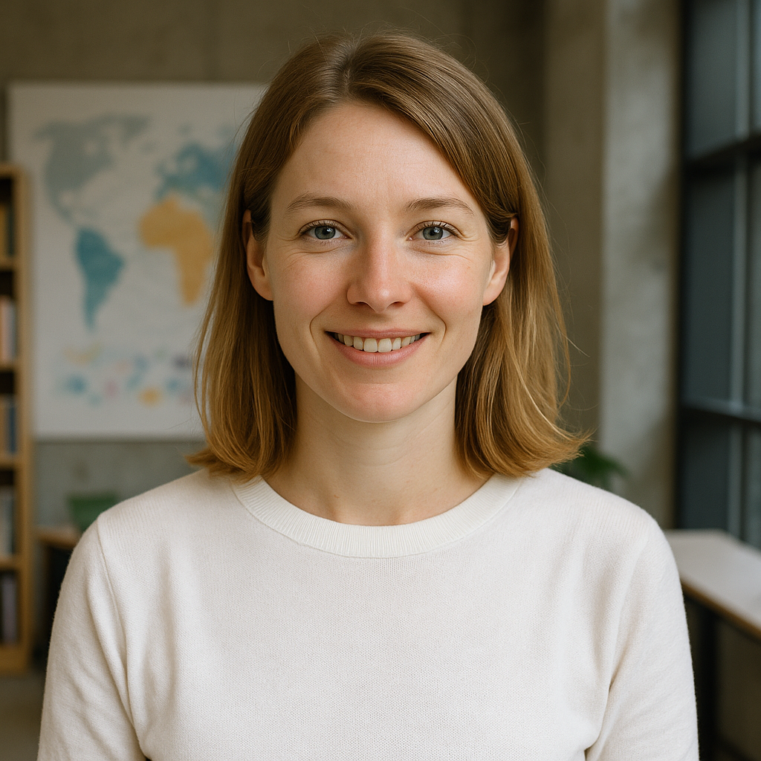
Picture 12 - Persona 2

Fluent in both German and English, Eva successfully balances her professional and family life. She lives in Hamburg with her husband, an energy engineer, and their 7-year-old son. Her professional work and personal interests are deeply intertwined, as she strives to make the future of culture and technology more accessible, not only through her research but also in her daily life.
Eva’s current focus on EXPO 2035 in Berlin highlights her multifaceted role as a researcher, facilitator, and family-oriented individual. Hosted in both physical and digital formats, the EXPO presents an ideal opportunity for Eva to explore climate, technological, and cultural models, drawing inspiration for her work while engaging in shared family experiences. Additionally, Eva supports her friend Amina’s research on how landscapes are changing due to climate impact, making the EXPO a place for both personal and professional connections. Through her participation, Eva seamlessly blends her academic curiosity with her commitment to involve her family in meaningful discussions about the future.
There exist several compelling reasons as to why Eva has been selected as a persona for the purpose of foresighting in the context of EXPO 2035. The most notable of these is her fluency in digital platforms and tools, which will enable her to fully engage with the virtual and hybrid format of EXPO. Given that a significant portion of the young population will be even more digitally fluent and reliant on technologies in 2035 than they are today (Anderson & Rainie, 2025), selecting a persona who embodies this characteristic is a logical choice.
In addition to her digital fluency, Eva's experience with cross-regional collaboration, particularly with Central and Southeast Asia, equips her to understand and envision how challenges are experienced in these regions. This broader perspective enables her to anticipate how different cultures and societies will respond to global trends and innovations, incorporating diverse global viewpoints rather than a narrow, localized one.
Finally, given the reality that Eva possesses a family adds another layer of depth to her persona within the foresight process. By planning to involve her family in the EXPO experience, the foresight scenarios can explore how future developments, whether technological, environmental, or social, will impact children as they grow up and the kind of world they will inherit. This ensures that future solutions, policies, and innovations are not only suitable for adults but also for future generations.

7.2. Journey Mapping

The process of journey mapping for the selected personas is critical when envisioning future scenarios, as it enables us to empathize with the individual and gain a deeper understanding of their experience. By mapping out their behaviors and emotional responses throughout their journey, we can better capture the nuances of their interactions and how they engage with future systems (Van Oosterom, 2016). Additionally, journey mapping offers the benefit of simplifying complex interactions by creating a clear representation of the entire process, outlining each stage to provide a comprehensive view of the user's experience (Gibbons, 2018). Finally, journey maps allow for the construction of scenarios that are not just futuristic but are also grounded in reality. This approach considers the real-world challenges and opportunities that the user may face, ensuring that the scenarios are both plausible and relatable (Fergnani, 2019).
Helga’s Journey Through the Virtual Expo
To understand how individuals like Helga would experience future systems under government mandates and digital infrastructures, this sub-section maps her step-by-step journey through the 2035 Virtual Expo, displayed in table 6, highlighting key actions, emotional states, and touchpoints - from the moment Helga receives the government directive to engaging with unfamiliar technology and confronting personal memories.
Table 6 - Helga’s Journey map
Stage | Touchpoints | Actions | Emotions
Awareness | Government-issued letter and radio announcement, linking participation to loyalty and portraying the government as the protector against climate threats. | Hears about obligatory Expo involvement | Hesitant, annoyed
Onboarding | Visit from a government employed outreach worker | Holographic pad/wearable is set up with verbal guidance on how to start the device. | Slightly reassured
Engagement | Interaction Mode | As the device boots on, Helga engages with a holographic AI assistant, which introduces herself and briefly explains the exhibition. | Curious
Exploration | AI-guided 3D holographic projection | The assistant projects 3D holograms, guiding Helga through the EXPO and sharing a local story of biodiversity loss—framed by the government’s efforts to restore it. | Skeptical
Emotional Hook | Audio-visual and physical memory cues | She opens a government-issued package containing dried herbs, just as a familiar folk tune begins to play. The AI assistant guides her into a virtual rural landscape - a serene scene of a young Bavarian gardener surrounded by wildflowers and thriving herbs. | Nostalgic
Memory Trigger | Emotional Memory Activation through Sensory-Driven Holography | As the image settles, Helga realizes the gardener is her younger self. The brittle herbs in her hands reflect not just ecological loss, but her own aging. Both her body and garden, shaped by time and a harsh climate, stir a quiet ache - reminders of a world, and a self, that once flourished. | Reflective
Learning | Narrative Hologram of Climate-Resilient Innovation | The AI assistant now depicts Helga in her present state, discovering and applying innovative methods to grow plants in her garden in climate-resilient soil. | Enlightened

Helga’s path reveals how systems such as EXPO 2035, while designed to be accessible to all, can still produce uneven experiences, offering insight into how future scenarios can be made more empathetic and inclusive, especially for the aging population. Moreover, Helga’s journey suggests that even in a future shaped by government mandates and climate urgency, meaningful and desirable outcomes can emerge from her participation, such as a growing sense of inclusion (albeit hesitant at first), a new awareness prompted by the assistant’s explanations and visual storytelling, and even a spark of agency as she adapts gardening methods to a changing climate. But perhaps the most profound outcome of her experience is her emotional reconnection: the dried herbs, familiar folk music, and evocative visuals from her past come together to trigger memory and feeling, creating a rare moment where technology becomes personal rather than alienating.
In the end, Helga may not come out of EXPO 2035 completely “converted” or digitally literate, but if designed well, she will leave it feeling recognized, with emotional resonance, and a seed of possibility. And that is a powerful return for someone who felt as if the future had passed them by.
Eva’s Virtual Journey Across the Scenarios
In order to better understand Eva's experience navigating EXPO 2035, the following table maps her virtual journey across the virtual event. Each stage of her interaction, from the moment she enters the platform, to when she selects a route for her and her family to experience, is highlighted alongside Eva's emotional responses, actions, and key touchpoints. This journey map (table 7) not only provides a detailed account of her immersive experience but also serves to illustrate how different aspects of the virtual EXPO influence her understanding of potential futures.
Eva’s journey through EXPO 2035 was one of deepened engagement and a strong connection to a future that seamlessly blends technology, global collaboration, and family ties. The advanced AR lenses and VR gloves allowed her to personalize her experience by creating an avatar that reflected her academic interests in multiculturalism and digital patterns, enhancing her immersion in the EXPO. This experience was further enriched by her ability to send invitations, participate in virtual conferences, and engage in dialogue with scientists, providing her with valuable insights into the evolving intersection of digital culture, climate change, and sustainability - insights that greatly informed her academic work on multiculturalism and digital transformation. Additionally, Eva’s experience was made more meaningful by her ability to invite her friend Amina to join her journey or switch to family mode to explore the future with her husband and son, effectively bridging both her professional and personal worlds.
Table 7 - Eva’s Journey map
Stage | Touchpoints | Actions | Emotional  Response
Entry to Platform | AR-lenses, sensor gloves, EXPO Sphere interface | Enters virtual space, sees main menu, selects "Send Invitation" | Curiosity, anticipation
Connecting with Amina | Identity confirmation system (voice + gesture + brain signature), avatar sync | Completes authentication, Amina appears, avatars synchronize | Excitement, warmth, connection
Exploring EXPO map | Interactive world map, pavilion nodes, voice chat | Navigates with Amina, discusses topics, touches interest points | Engagement, shared discovery, reflective interest
World Simulation Pavilion | Four portals with visual immersion | Visits all 4 scenarios, observes differences, shares insights | Cultural excitement, hope, anxiety, critical thinking
Conference Participation | Virtual amphitheater, voice interface, expert speaker, Q&A system | Listens to a talk, then proceeds to ask a question and receives a follow-up meeting offer | Intellectual stimulation, pride, relevance
Warm farewell | Quite digital dome, virtual river | Chats with Amina, proposes joint project, shares emotional closure | Warmth, appreciation, inspiration
Family mode | Family route selector, child-friendly digital environments | Sends link to family, plans shared exploration | Playfulness, joy, care, connection

Conclusion

The "Future of Expo 2035" project represents a forward-thinking and comprehensive exploration of how global mega-events might evolve in the face of accelerating technological, political, and environmental change. Using a structured foresight methodology, our team identified and assessed potential key drivers, developed multidimensional scenarios, and envisioned diverse experiential futures through immersive storytelling and prototype-based design.
Our four scenarios, structured around the polar outcomes of governance and climate resilience, offer a spectrum of plausible futures - from inclusive, technologically integrated, and environmentally resilient societies to fragmented, authoritarian, and climate-vulnerable environments. Each scenario not only captures potential paths but also highlights the ethical, logistical, and cultural implications of decisions made today.
What emerges from this work is a powerful recognition that Expo 2035 is not merely an event - it is a reflection of collective priorities. The ability to create livable, inclusive, and sustainable futures depends on how governments, designers, technologists, and citizens navigate critical uncertainties around democratic participation, technological governance, and climate adaptation.
Through this foresight project, we conclude that Expo 2035 presents an opportunity to serve as a prototype for more equitable and adaptive urban futures - a platform where digital citizenship, sustainability, and cultural plurality converge. Whether we move toward a livable and multicultural world or face fractured, exclusionary alternatives depends on the choices made today in policy, design, and technology.
Ultimately, the scenarios serve as more than speculative visions - they are tools for dialogue, planning, and preparedness. They compel us to confront uncomfortable possibilities while inspiring bold, inclusive action. The future is not fixed, but forged - together.

References

- Anderson, J., & Rainie, L. (2025). Being human in 2035: How are we changing in the age of AI (pp. 37–39). Available from: Being-Human-in-2035-ITDF-report.pdf
- Bureau International des Expositions. (2025). What is an Expo? https://www.bie-paris.org/site/en/expos/about-expos/what-is-an-expo
- Candy, S., Perceived usefulness, perceived ease of use, and user acceptance of information technology experiential scenario: The People Who Vanished. Futures, 86, 136–153. https://doi.org/10.1016/j.futures.2016.05.006
- Cordova-Pozo, K., & Rouwette, E. A. J. A. (2023). Types of scenario planning and their effectiveness: A review of reviews. Futures, 149, Article 103153. https://doi.org/10.1016/j.futures.2023.103153
- Davis, F. D. (1989). Perceived usefulness, perceived ease of use, and user acceptance of information technology. MIS Quarterly, 13(3), 319–340. https://doi.org/10.2307/249008
- Ellen MacArthur Foundation. (2022). Circular economy introduction. https://ellenmacarthurfoundation.org/topics/circular-economy-introduction/overview
- Expo 2020 Dubai. (2022, April 11). Virtual Expo. https://www.expo2020dubai.com/en/news/virtual-expo
- Fergnani, A. (2019). Futures and foresight: Designing powerful narrative scenarios. Foresight, 21(4), 435–448. https://doi.org/10.1108/FS-01-2019-0001
- Gibbons, S. (2018). Journey mapping 101. Nielsen Norman Group. Available from: https://www.nngroup.com/articles/journey-mapping-101/
- International Energy Agency. (2019). The future of hydrogen: Seizing today’s opportunities. https://www.iea.org/reports/hydrogen
- J. Stories. (2025, May 23). Digital and physical realities intersect. https://jstories.media/article/digital-and-physical-realities-intersect
- Mangnus, A., Vervoort, J., Ingram, J., Kok, K., & Helfgott, A. (2021). Re-imagining the future: The use of transformative scenarios. Futures, 127, 102712. https://doi.org/10.1016/j.futures.2020.102712
- Pace, L. A., Bruno, C., & Schwarz, J. O. (2025). Personas in scenario building: Integrating human-centred design methods in foresight. Futures, 166, 103539. https://doi.org/10.1016/j.futures.2023.103539
- Pruitt, J., & Adlin, T. (2006). The persona lifecycle: Keeping people in mind throughout product design. Morgan Kaufmann.
- Rutting, L., Vervoort, J., Mangnus, A., & Helfgott, A. (2024). Power and participation in futures: Exploring who decides. Futures, 144, 103567. https://doi.org/10.1016/j.futures.2023.103567
- Schwarz, J. O. (2023). Strategic foresight: An introductory guide to practice (1st ed.). Routledge. https://doi.org/10.4324/9781003302735
- Van Oosterom, A. (2016). Why & how: Some thoughts on personas, journey mapping & implementing design thinking. Available from: https://issuu.com/alexvno/docs/why_and_how_personas_and_journey_m
- Wikipedia. (2024, March 18). World Expo. https://ru.wikipedia.org/wiki/Всемирная_выставка

Appendix

Appendix 1

Individual Contributions to the Project Report

Name member team | Responsibility for the design of the content of the teamwork report section |  | Responsibility for Website the project website on the Canva platform
 | № Chapter | Pages | design of the sections/  website | developed a video
Zhanl Mamykova. Matr. No.00172672 | 1.1  1.2  5.1  5.2 | 5-6  6-7  24-26  27-29  Total: 8 p. | - web-design for the project website  - Scenario 1  - Persona 2 | - Scenario 1  - Persona 2
Haroon Marzook. Matr. No. 00172055 | 7.  7.1  7.2 | 39  40-42  42-45  Total: 7 p. | - Persona 1 | - Persona 1
Abdul Razaque Pirzado. Matr. No. 00164580 | Introduction  5.5  6.1  6.2 | 4  33-35  36-38  38  Total: 6 p. | - Implications  - About team
Bhushan Shirsath. Matr. No. 00172884 | 4.1  4.2  4.3  Conclusion | 13-14  14-16  16-23  46  Total:12 p. | - Scenario Matrix  - Scenario 3  - Scenario 4 | - Scenario 3  - Scenario 4
Shubham Jawale. Matr. No.00172581 | 2  5.4 | 8-10  31-33  Total: 6 p. | - Introduction  - Trends cards
Mangesh Bharat Borude. Matr. No. 00171191 | Abstract  3  5.3  References | 2  11-12  29-30  47-48  Total: 7 p. | - Relevance/ Uncertainty  - Scenario 2 | - Scenario 2

Appendix 2

Code of AI Ethics & Research Transparency

Student name: Zhanl Mamykova, Haroon Marzook, Abdul Razaque Pirzado, Bhushan
Shirsath, Shubham Jawale, Mangesh Bharat Borude
Course name: Global Foresight and Technology Management
Assignment Title: Project Future Life Worlds "The Future of EXPO World Exhibition" Date:
07.07.2025
I hereby confirm that I understand the importance of academic integrity and the responsible use of artificial intelligence (AI) in the research process. By signing this Code of AI Ethics and Transparency, I commit to the following principles and guidelines in the preparation and submission of my assignment:

Honesty and Transparency:
I hereby disclose the use of AI tools, such as (but not limited to) ChatGPT, in my research process. This includes specifying the tasks for which AI was employed, such as literature review, data analysis, or idea generation:

For which parts and aspects of the research process have you used any kind of AI?

Please, provide a short summary regarding the use of AI in your assignment:
We used ChatGPT to support the writing of narrative texts for our scenarios and to generate images based on our original ideas and prompts, aslo to check APA-style formatting. In addition, we used other AI tools to create videos with voice-over narration.

Originality and Attribution:
I ensure that my work is original and properly cited. If AI-generated content is included in my submission, I have clearly indicated the source and provided appropriate attribution.

Critical Thinking and Evaluation:
I have critically evaluated the information and insights provided by AI tools, cross- checking their accuracy and relevance to my research topic. I did not rely solely on AI- generated content and have engaged in independent analysis and interpretation.

Ethical Use of AI: I have used AI tools responsibly and ethically. I have not used AI to plagiarize, fabricate data, or engage in any other form of academic dishonesty.
Acknowledgment of AI Limitations: I recognize that AI tools have limitations and biases, and I will take these into account when incorporating AI-generated content into my research. I will strive to minimize the impact of these limitations on the quality and integrity of my work.

By signing this document, I affirm that I have adhered to the principles and guidelines outlined above in the preparation and submission of my assignment.
